**CS 100 PROJECT**

Muhammad Junaid Riaz

[Company name]  [Company address]

**ELECTRONIC POINT OF SALE FOR J.F ENTERPRISES**

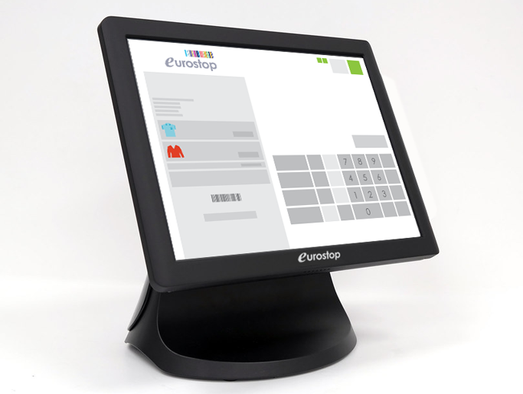

**Muhammad Junaid Riaz 23110164**

**Syed Muhammad Farghab Jaffery 23110194**

**ELECTRONIC POINT OF SALE**

**Showroom’s menu**

* An interface of items offered by J.F Enterprises and their respective prices.

**Identifying the user**

* User is asked whether he is an employee or not.
* If yes, user is asked for email and password to verify him*.
* If email misses “@” or “.com” then user is required to input, the email again.
* If email is wrong but includes “@” and “.com” program stops.
* Once email is matched, user is required to input password.

**Adding Inventory**

* If user is an employee, he is asked if he has to add inventory.
* If no inventory needs to be added, program will continue to billing system.
* If inventory needs to be added, then no billing system and program ends once inventory is added.
* For adding inventory, user will be asked to enter the corresponding number of the item and its quantity that needs to be added.
* User will be asked for adding inventory until he don’t want to add and types “N”.
* The program then ends.

**Billing system**

* On entering “N” for the question of whether the user is an employee or not, program goes directly to the billing system.
* An employee can also go to the billing system if he enters “N” for adding inventory question.
* User is asked to enter the corresponding number of the item that he wants to buy and its quantity.
* User is asked until he types “Nothing”.
* User is asked whether he is a member or not and if yes, he is asked to add membership code.
* If membership code starts from “P” then discount given is 10% to special customers.
* If membership code starts from “R” then discount given is 20% to very special customers.
* User is told its bill so that he can prepare cash accordingly.
* If cash he gives is less than the total bill, user would be asked to reenter the cash he is giving and will be told the amount left to be paid.
* A receipt will be printed that will tell the item bought, its respective quantity, unit price and total price for that item.
* Receipt will tell the total bill of all the different items bought, discount given, cash received, and cash returned.

**Code overview**

Code was made and run on VISUAL STUDIO where it worked perfectly. Code involves file reading for items that J.F ENTERPRISES offers, price for each item, credentials for our employees, membership codes and inventory level. The content of these files are stored in arrays. Code also includes file writing of inventory file at the end after the user has either bought or added the inventory. We incorporated these reading and writing of files in functions. Another function for receipt was made. These functions were then called in main when required. Code involves commenting so that the reader knows what our every command is doing.

In addition to functions, main function includes the code for validating if a person is an employee or not by verifying email and password. Code also includes matching items with its respective prices and calculating the total bill while deducting discount if user has the membership. Finally, a receipt is printed showing what user has bought. Our receipt and interface was coloured using a small segment that was written before and after what we wanted to print.

*Following emails and password can be used for employee verification:

junaidriaz@gmail.com

Attockcity

farghabjaffery@gmail.com

Voicenote

haiderbangash@gmail.com

Horserider

arhamnadeem@gmail.com

Sahiwalpakistan

hassanbashir@gmail.com

Csking

muneebchisti@gmail.com

Cfrinterfinn